1. ipconfig: It displays the configuration of network interfaces on a Windows computer, including IP addresses and related information. It is used to diagnose and troubleshoot network connectivity issues.

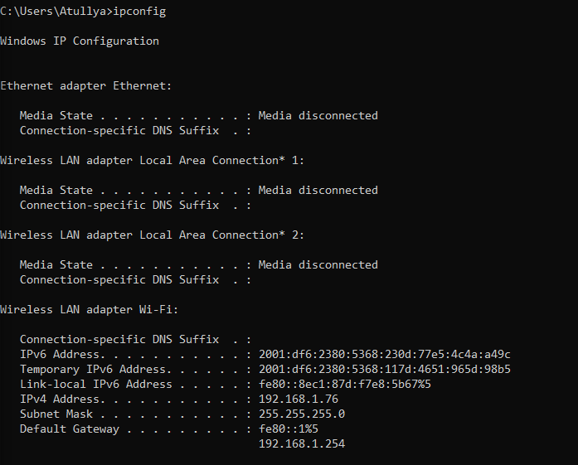

1. It provides detailed information about all network interfaces, including IP configurations, DNS settings, physical addresses, and more, offering a comprehensive view of the network configuration on a Windows system.

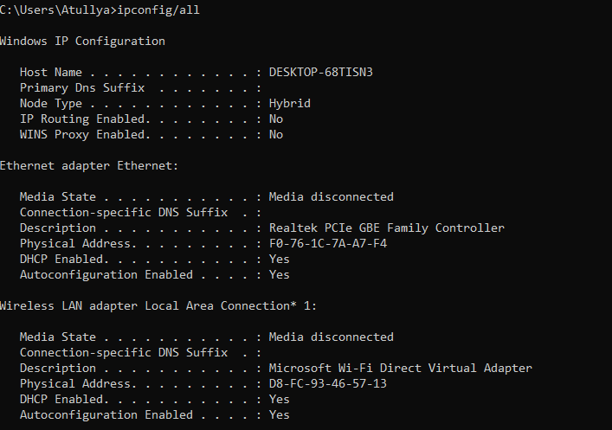

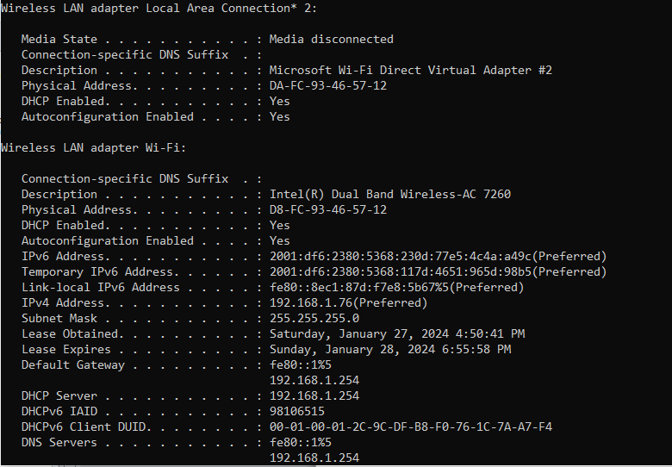

1. nslookup: It allows users to look up various DNS records, such as IP addresses associated with domain names, or vice versa. This tool is commonly used for troubleshooting network issues, checking DNS configurations, and obtaining information about domain name resolution.

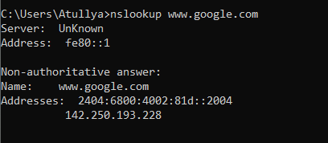

1. ping: It sends Internet Control Message Protocol (ICMP) echo requests to a target host, measuring the round-trip time for data transmission and assessing network connectivity. It is commonly used for network troubleshooting and verifying the availability of a host on an IP network.

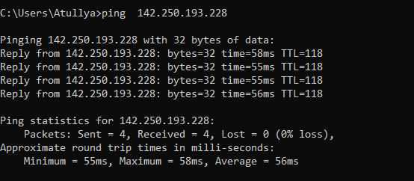

1. tracert: It displays the series of routers or intermediate devices that the packets pass through, showing the time it takes for each hop. tracert is useful for diagnosing network connectivity issues, identifying bottlenecks, and analyzing the path of data packets across the Internet.

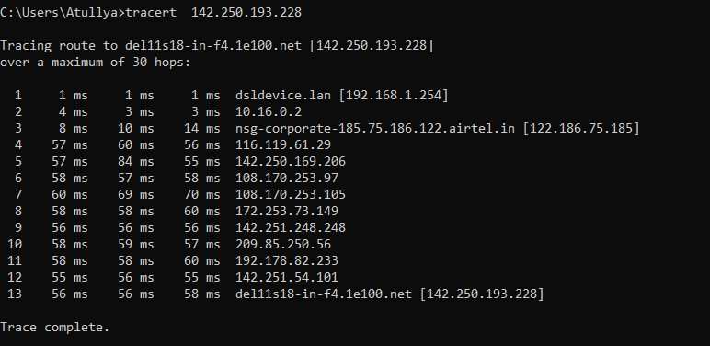

1. getmac: It retrieves the Media Access Control (MAC) address for one or more network adapters on a computer. The getmac command provides a convenient way to view the physical addresses of the network adapters installed on a Windows system.

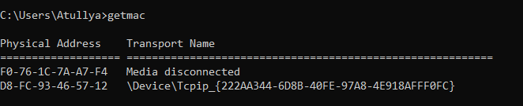

1. arp –a: It is used to display the Address Resolution Protocol (ARP) cache on the local computer. It shows a table that maps IP addresses to corresponding physical MAC addresses for devices on the local network.

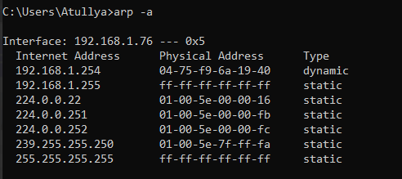

1. netstat: It display network-related information on a computer. It provides information about network connections, routing tables, interface statistics, masquerade connections, and more. netstat is commonly used for diagnosing network issues, monitoring network activity, and understanding the state of network connections on a system.

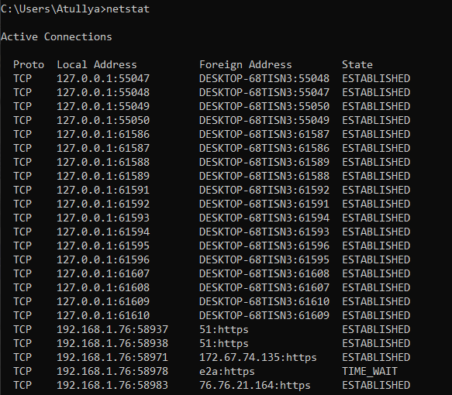

1. hostname: It is used to display the hostname of a computer in a command-line interface. It returns the name that has been assigned to the device on the network

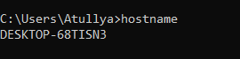

1. nbtstat: It is used to display NetBIOS over TCP/IP (NBT) information. nbtstat can show information about NetBIOS name resolution, NetBIOS statistics, and the NetBIOS name table. It is often used for troubleshooting NetBIOS-related issues on a network.

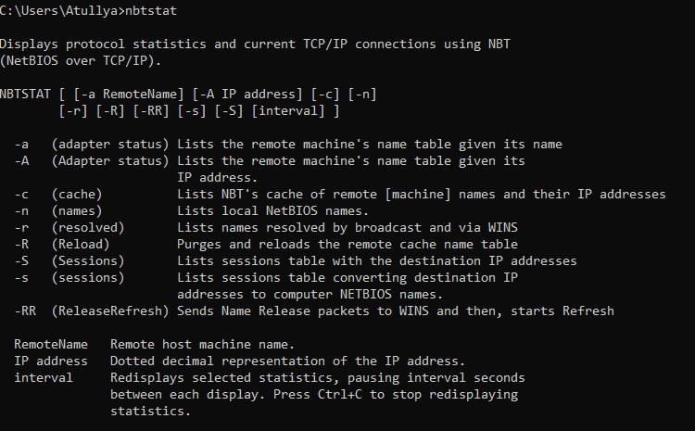

1. nbtstat –n: The nbtstat -n command is used to display the NetBIOS name table, which contains a list of NetBIOS names that the computer has registered and their corresponding IP addresses

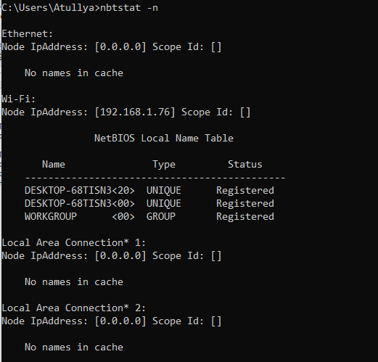

1. route print: It is used in a command prompt or terminal to display the current IP routing table on a computer. It shows information about the routing table, including network destinations, subnet masks, gateways, interface metrics, and more. This command is commonly used for diagnosing and troubleshooting network connectivity issues, as it provides insights into how the system routes data packets to different network destinations.

